PROJECT SPECIFICATION

Project Name : Working Voices Choir Website (WVC Website)

Version Control:

|  |  |  |  |
| --- | --- | --- | --- |
| Version | Date | Author | Description |
| 1.0 | 14/05/2011 | Kiki Susanto | First Draft |
| 2.0 | 19/05/2011 | Kiki Susanto | Second Draft |
| 3.0 | 26/05/2011 | Kiki Susanto | Final Version |

**Distribution List:**

|  |  |  |  |
| --- | --- | --- | --- |
| **Name** | **Position** | **Signature** | **Date** |
| Dr. Rob Phillips | WVC Project developer/ Sponsor |  |  |
| Stephen Hastings Tony Evans Helen Burgess Sue Williams | Consultant Project Manager Consultant Design Consultant Programming Consultant Testing |  |  |
| Kiki Susanto | Project Manager |  |  |
| Alexander Oliver Peter Hickey  Meor Hozey Zackary | Team Member Design Team Member Programming Team Member Testing |  |  |

Contents : 1. Project Objective

2. User Requirements

3. Success Criteria

4. Site Map

5. Functional Specification

6. Technical Specification

7. Content plan

8. Testing Plan

9. Site updates and Maintenance

10. Critical Path

11. Budget

12. Appendix

 Project Brief – refer to separate WVC Project document

 Project Resources

 Assumptions

 Risk Management – refer to separate WVC Project document

Introduction :

This Project Specification is the main project documentation of the Project WVC Website.

Not to have too much duplication, some documents are just referred to that particular documentation and not repeated here. Only a brief summary of those documents is outlined here.

Appendixes belong to WVC Technical Documentation is: Design Concepts, Change Control Process and Intellectual Property.

1. Project Objective:

**Create a Web site for Working Voices Choir with major objectives:**

* **To publicize the choir in order to attract new member.**
* **To promote the choir in order to get more gigs.**
* **To keep an up-to-date list of choir events – past and future.**
* **To provide a generic member login that will enable choir members to**
* **Download sound files of choir songs.**
* **Download copies of the sheet music for choir songs**
* **Download lyrics of choir songs,**
* **Update choir member contact details.**

2. User Requirements :

**1. The general public need to have access to this following information :**

* The history of the choir
* The range of songs sung by the choir. This would be by category, showing title and a brief description of the song. Also a short sound bite. There could also be an area for on-going background information for each song. (This is also useful for song intros at concerts.)
* A list of past choir gigs
* Future gigs
* How to join, costs and rehearsal venue address.
* Details about the musical director.
* There should be a form for potential gig organizers to register their interest
* There should be a form for potential singers to register their interest and ask questions.
* A poster that potential gig organizers can download, customize and print.
* A comments area for concert feedback.

**2. Members of the choir should be able to log-in using a generic log-in in order to:**

* Register and update their contact details
* Download song sound files for learning purposes.

These will be organized within song title by voice part.

* Download the sheet music for the song of choice.
* Download a copy of the lyrics (either in the one document with all songs – the “crib sheet file”) and/or separately as well.
* Post information of interest to choir members. This will duplicate at times information that is included in “choir mail-outs” by email, which should continue.
* Up-to-date information regarding up-coming gigs.

3. Success Criteria :

1. Working Voices Choir Website is up and working well, can be accessed from around the world.

2. There is an increase in Membership inquires.

3. There is an increase in new gig / performance booking by the website.

4. Members find it easy to use the website and the learning / rehearsing facilities.

5. Administrator can conveniently maintain and update the songs database.

6. Members can easily update their own personal data such as, email address, home address, phone number and mobile phone number.

7. Webmaster (with certain qualification) can maintain contents of the website’s pages.

4. Site Map : please refer to next page.

4. Site Map :

|  |  |  |  |
| --- | --- | --- | --- |
| Home Page |  |  |  |
|  | Events |  |  |
|  |  | Past Events |  |
|  |  | Future Events |  |
|  |  | Choir Bookings |  |
|  | Songs |  |  |
|  |  | Public area |  |
|  |  | Member area (requires Login) |  |
|  | Gallery |  |  |
|  |  | Public area |  |
|  |  | Member area (requires Login) |  |
|  | About Us |  |  |
|  |  | What WVC aims at |  |
|  |  | Info about issues covered by the choir |  |
|  |  | History of WVC |  |
|  |  | Rehearsal Location and schedule |  |
|  |  | Joining and membership fee |  |
|  |  | Musical director |  |
|  | Links |  |  |
|  |  | Links to Affiliates websites |  |
|  | Joining Form | |  |
|  |  | Joining Form |  |
|  | Login |  |  |
|  |  | Login Form |  |
|  |  |  |  |
|  | Member News (requires Login) | |  |
|  |  | Member News |  |
|  | Footer |  |  |
|  |  | Contact Us |  |
|  |  |  | Contact Form |
|  |  | Terms and conditions / privacy |  |
|  |  | Disclaimer |  |
|  |  | Webmaster |  |
|  |  | Copyright |  |
|  |  | Admin (requires Login) |  |
|  |  |  | Songs Database |
|  |  |  | Events blog control |
|  |  |  | Events Database |
|  |  |  | Gallery control |
|  |  |  | Bookings control |
|  |  |  | News control |

5. Functional Specification.

**1. Navigation system.**

Web pages of Working Voices Choir Website will be supplied with Navigation Menu

and sub menu as described in 4. Sitemap.

* at the left hand side

Home, Events, Songs, Gallery, About Us,

* at the right hand side

Links, Joining Form, Login, Member News

* at bottom

Contact Us, Terms and Conditions / privacy, Disclaimer, Copyright, Webmaster,

and Admin (requires Login).

**2. Dynamic Data Contents.**

These are website page’s dynamic data contents, that will be kept in WVC Database.

* Member contact details, maintained by member self:.
* Choir booking, events comment and joining choir form: entered by public:
* Songs Database, Events comments, Events Database, Gallery control (through Picasaweb), Choir Bookings control, News control: maintained by administrator.

Every dynamic data content will have an entry form, edit form and delete facility.

Ability to add new content at specified location in display, and change the order of content – e.g. songs

Following contents will need Administrator’s release action (moderation mode) to be viewable:

* Events comment.

After Administrator’s release, events comments are viewable by public.

* Choir Bookings.

After Administrator’s release, choir bookings are viewable by members.

Gallery page will link closely to picasa (please refer to <http://picasaweb.google.com>

For picasa functionalities).

Gallery page will show picasa album only (its page size’s picture is clickable to WVC picasaweb website).

**3. Wireframe.**

Shows each website’s page layout.

Please refer to separate document.: WVC Wireframe.

**4. Prototype.**

Available at:

<https://sites.google.com/a/certfour.com/wvc/>

and

http://www.workingvoiceschoir.org.au

6. Technical Specification.

Please refer to Technical Specification document, which contains detail check list of:

1. Target Specifications

2. Functionality / Features

3. Design / Layout / Code

4. File Structure / Directory Preferences

5. Server / Hosting Information

6. Website Style Guide

7. Details of unique pages

8. Intellectual Property / Copyright register

9. Visual / Page Layout Diagram (same as WVC Wireframe).

7. Content Plan:

Following is the content inventory of WVC website, there are 24 pages for this website..

|  |  |  |  |  |  |
| --- | --- | --- | --- | --- | --- |
| Page ID | Page Name | Link | Type | Keywords | Notes |
| 1.0 | **Home** | index.php | html + php | working voices, choir, song, music | WVC home page |
| 2.0 | **Events** | events.php | html + php | choir, events | WVC events |
| 2.1 | Events- comment | comment.php | html + php | choir, events, comments | WVC events comment |
| 2.2 | Events- enter | events2.php | html + php | choir, events | WVC events new entry |
| 2.3 | Events- update | events3.php | html + php | choir, events | WVC events update |
| 2.4 | Choir-Booking | choirbooking.php | html + php | choir, events, booking | WVC choir booking |
| 2.5 | Choir-Booking-Review | Choirbooking2.php | Html + php | Choir, events, booking | WVC choir booking review |
| 3.0 | **Songs** | songs.php | html + php | choir, songs | WVC songs |
| 3.1 | Songs- enter | songs2.php | html + php | choir, songs | WVC songs new entry |
| 3.2 | Songs- update | songs3.php | html + php | choir, songs | WVS songs update |
| 4.0 | **Gallery** | gallery.php | html + php | choir, gallery | WVC picture gallery |
| 5.0 | **About Us** | about.php | html + php | about WVC, choir | About WVC |
| 6.0 | **Members** | members.php | html + php | choir, member | WVC Members Only |
| 6.1 | Members- update | members2.php | html + php | choir, member |  |
| 7.0 | **Joining Choir** | joining.php | html + php | choir, joining | Register to be WVC Member |
| 7.1 | Joining Choir Review | Joining2.php | Html + php | Choir, joining | WVC joining choir review |
| 8.0 | **Login** | login.php | html + php | choir, login | WVC Member login &  Administrator Login |
| 9.0 | **Member News** | news.php |  | choir, news | WVC Member news |
| 9.1 | News- Enter | news2.php | html+php | choir, news | WVC Member news entry |
| 9.2 | News- Update | news3.php | html + php | choir, news | WVC Member news update |
| 10.0 | **Contact US** | contact.php | html + php | choir, contact | WVC Contact |
| 11.0 | **Terms and Conditions** | Termsandcond.php | Html + php | Terms, conditions | WVC terms and conditions |
| 12.0 | **Disclaimer** | disclaimer.php | html + php | choir, disclaimer | WVC Dislaimer |
| 13.0 | **Copyright** | copyright.php | html + php | choir, copyright | WVC Copyright |

**Note: Link and Page type is subject to change to Ruby on Rails implementation.**

8. Testing plan.

Testing will be performed in stages :

1. Unit test by Programmer and Designer.

2. Integration test by Programmer and Tester.

3. System test by team of Web Designer and Hosting Site as well as WVC representative.

4. Acceptance Test, Accessibility and Usability Test by WVC representative with support from Web Designer team.

After completion of acceptance test, the web site can enter implementation phase.

Testing will be performed using various browsers : IE, Mozilla, Chrome on various monitor size and modest PC configuration, on site as well as off site to measure response time.

Schematic picture on following page show the Testing Tasks environment (enclosed in red dotted line).

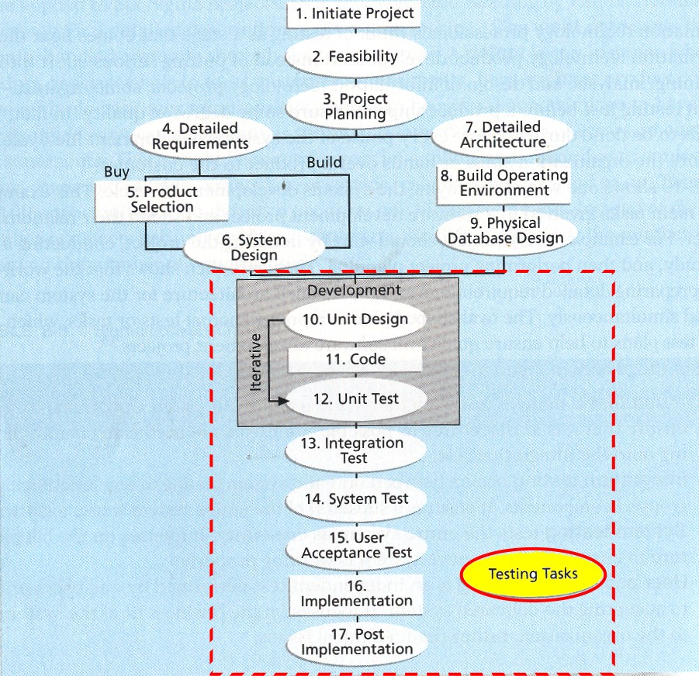

9. Site updates and Maintenance.

Here are site updates and maintenance plan for WVC website:

9.1 Data contents (page dynamic contents).

9.1.1 New Events, New Songs, New Gallery Album and New Member News are entered by Administrator.

9.1.2. Events, Songs and Member News are updated by Administrator.

9.1.3. Events, Songs, News and Member data are deleted by Administrator.

9.1.4. Member data are entered by member self .

9.1.5. Member data are updated by member self.

9.1.6. New Events Comments and Choir Bookings are entered by public.

9.1.7. Events Comments and Choir Bookings are reviewed and released for publication by Administrator.

9.1.8. Events Comments and Choir Bookings are deleted by Administrator.

9.1.9. Gallery pictures (to picasa) are uploaded by Administrator.

9.1.10. Gallery albums are entered, updated and deleted by Administrator.

9.1.11. Public Gallery pictures comments are entered by Public (picasa facility)

9.1.12. Member Gallery pictures comments are entered by members (picasa facility)

9.1.13. Gallery pictures comments are deleted by Administrator (picasa facility).

9.2 Page static contents (including page layouts) are updated and maintained according to Site updates and Maintenance plan of the WVC Website.

9.3 Data Base Table structure maintenance is also covered in Site updates and Maintenance Plan of the Website.

10. Critical Path (Gantt Chart).

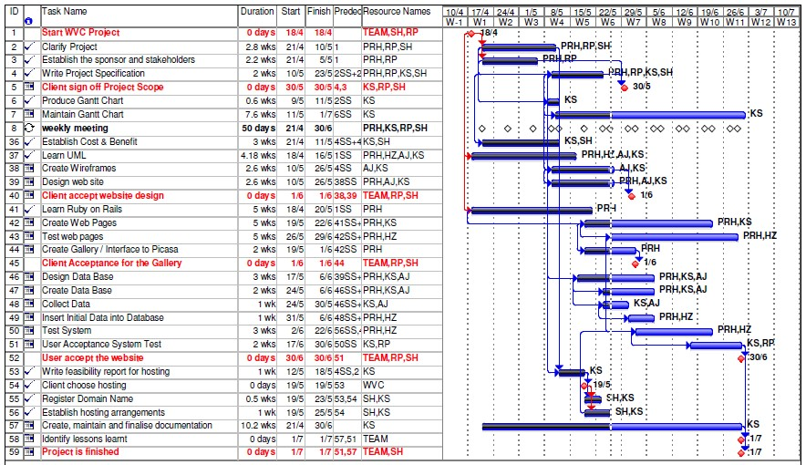

There are 2 critical paths in this project:

1. Learn Ruby on Rails-create web pages-test web pages.

2. Test System – User Acceptance System Test

11. Budget.

Domain Name Registration and Web Hosting $124.73 for 2 years, starting 25 May 2011.

12. Appendix.

 Credentials

 Project Brief – refer to separate document in WVC Project Scope documentation

 Project Resources

 Risk Management – refer to separate document in WVC Project Scope documentation

12. Appendix.

 **Credentials**

**INSTITUTION**

Central TAFE is really a proven education institution in particular in IT and Web Design.

**PERSONAL**

2 member teams are long term University graduates and have had real business –entrepreneurship.

All 4 of team members have got **Certificate 4 IT / Web Design**, familiar and skillful in:

1. Dreamweaver CS5

2. HTML & CSS programming

3. Javascript and jQuery

4. PHP

5. Adobe Photoshop CS5.

6. SQL and MySQL Database

1 team member is familiar with Ruby on Rails.

We have developed various other websites :

1. Kiki Susanto personal web page (in process of moving the hosting site).

2. Internet Station web page: **http://is.cc68.org**

3. The Market Place: **http://tmp.cc68.org**

4. Frosti Wear: **http://fw.cc68.org/frosti.htm**

5. Twinlife Magazine: **http://tlf.cc68.org**

6. CSS Zen Garden: [**http://zen.cc68.org/zengarden-sample.html**](http://zen.cc68.org/zengarden-sample.html)

7. Corvette Veterans Club: **http//cvc.cc68.org**

8.Corvette Veterans Club (Kiki Susanto’s version): **http://cvc-ks.cc68.org**

9. Holy Family Church : [**http://www.holyfamily.com.au**](http://www.holyfamily.com.au)

10. Alumni CC68: [**http://www.cc68.org**](http://www.cc68.org)

11. Perth Woman Magazine: **http://perthwoman.com.au**

13. Appendix.

 **Project Resources**

**Human Resources**

1. 4 person in a team, each responsible for Project Management, Design, Programming and Testing.

2. 4 central TAFE expert consultants for Project Management, Programming, Design and Testing

3. Other project team members.

**Hardwares**

1. PC in TAFE class, in library and at home, including printers, scanners, digital cameras.

2. Portable harddrive

3. PC at hosting site.

**Softwares**

1. Dreamweaver CS5 available at TAFE class rooms and at home

2. MS-Word, MS-Excel and MS-Project are available too.

3. Apache XAMPP installed in our portable drive, and at home we have WAMP as test environment.

4. PHP, MySQL and Ruby on Rails are installed and available in our portable drive, home computers. and

on our hosting site.

5. phpMyAdmin and cPanel are ready for use.

**Books / reference manual**

1. Necessary books related to the CMS, PHP, HTML, CSS, Project Management, Photoshop are all identified and found in library.

2. Some good books are purchased and ready at all time to refer to.

3. And searching additional support information from internet, using Google is always be performed.

**Sign off**

|  |  |  |
| --- | --- | --- |
| Date :  Working Voices Choir  Robs Signature.pngSubject to change noted under 5.2  Dr Rob Phillips | Date :  Central TAFE  Stephen Hastings | Date :  Project Manager  Kiki susanto |

 